DEC Recommended Practices Topic Area: INSTRUCTION
Practitioner Practice Guide: Instruction 2.1 Embedded Instruction Practices
Embedded instruction involves multiple, brief teaching interactions between a teacher and child during everyday classroom activities. By identifying functional behavior targets, selecting classroom activities best suited for embedded learning opportunities, and using planned and intentional instructional strategies, teachers can help children learn new behavior for participating in classroom activities throughout the day.
Watch a video of this Learning Guide
Learning Guide: Planning and Using Embedded Instruction Practices
- Identify behavior and skills the child needs to learn in order to participate in everyday classroom activities. Observe the child in different activities to determine which child behavior would be useful and important for promoting the child’s engagement and independence in the activities. Select target behavior that build on the child’s current capabilities.
- Examine the classroom schedule to identify those activities and routines that would provide opportunities for the child to use the target behaviors. Select times of the day and classroom happenings where the behavior likely would occur as a natural part of participation. Embed learning opportunities across different activities and routines that are of interest to the child.
- Arrange the environment in ways that ensure the child’s engagement in the selected activities and cue the child to the target behavior. For example, to encourage a child to use a gesture and vocalization to request an object, provide toys and materials of interest to the child and set them slightly out of reach. routines that are of interest to the child.
- Pay attention to the child while he or she is engaged in the selected activities. Join in the child’s activity and take turns with the child to keep him or her engaged. When the child shows interest in an object or action, prompt the child to use the target behavior by providing a cue (e.g., looking at the child expectantly), asking a question (e.g., “What would you like to do?”), or giving an instruction (e.g., “Tell me what you want.”).
- Provide the child assistance to ensure that he or she has success doing the target behavior. You can draw the child’s attention to the “correct” behavioral response by pointing or tapping an appropriate object. Demonstrate the target behavior by providing a verbal or physical model. If needed, assist the child physically to help him or her do the behavior (e.g., provide hand-over-hand assistance). Provide the child enough time and only as much support as needed to do the target behavior. Decrease the amount of assistance as the child learns the target behavior.
- Respond positively to the child’s use of the target behavior. Provide descriptive praise, access to the toys or materials of interest, assistance in doing a desired action, or continued participation in the activity. Provide the child multiple opportunities to use the target behavior in different activities throughout the day.
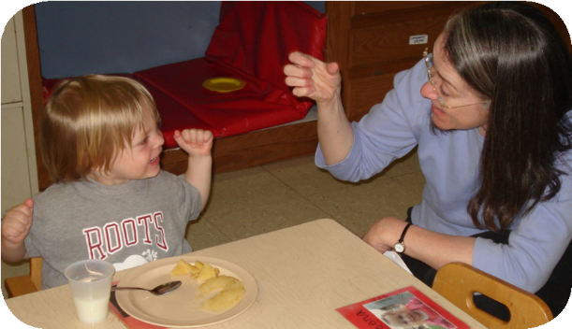A Quick Peek
After observing Tucker in different classroom activities, Peg and the other classroom teachers determined that he could have more participation in activities if he were able to use simple signs to label desired objects and materials. They decided to embed numerous opportunities for learning several signs during the activities he most enjoyed. They determined that they could use activities such as lunchtime, morning and afternoon snack, and playtime in the home living area to embed opportunities for learning to make the sign for milk. During snack time, Peg watched as Tucker reached for his cup of milk. Peg smiled at Tucker and said, “What do you want to drink?” Tucker looked at her, grinned, and looked at the cup of milk. Peg made the sign for milk as she said, “Milk? You want milk?” After Tucker looked at his cup again, Peg said, “Milk,” helped him make the sign for milk, and then gave him the cup of milk to drink. Peg and the other teachers gave him many opportunities during the selected activities to make this sign. Gradually, they needed to provide him less help, and soon, when Tucker was ready for something to drink, he eagerly could look at Peg and make the sign for milk.

You'll know the practice is working if ...
- Children stay engaged in everyday classroom activities and routines
- Children learn and use new behavior during different classroom activities
- Children are more independent participating in different classroom activities

Learn more about embedded instruction in online resources:
- Embedded Instruction for Early Learning
- Embedding Instruction for Children with Disabilities in Inclusive Community Settings Inclusive Community Settings

© 2017 Early Childhood Technical Assistance Center different classroom activities http://www.ectacenter.org/decrp

